Plants Test Study Guide
A proficient student can summarize the basic structures and functions of flowering plants required for survival, reproduction and defense
1. Why do plants have flowers?

2. What are the function and locations of the following terms:
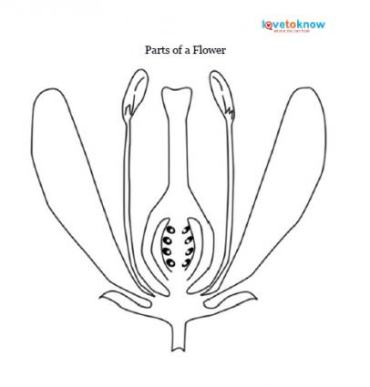
a. Phloem
b. Xylem
c. Petal
d. Sepal
e. Pistil
f. Ovary
g. Ovule
h. Style
i. Stigma
j. Stamen
k. Filament
l. Anther
m. Pollen
n. Leaves
o. Roots
p. Stem
q. Stomata
3. What is the difference between a perfect and an imperfect flower?

4. Describe the process of pollination and explain why it is important.

5. Describe the process of fertilization and explain why it is important.

A proficient student can explain the processes of photosynthesis, respiration, and transpiration to the survival of green plants and other organisms.
- Explain the process of photosynthesis and why it is important.

- Where does photosynthesis occur?
3. What is the chemical equation for photosynthesis?

4. Explain the process of cellular respiration and why it is important?

5. What is the chemical equation for cellular respiration?

6. Where does cellular respiration occur?

7. How are the processes of photosynthesis and cellular respiration related?

8. Explain the process of transpiration and why it is important.

9. Why is transpiration important to plants?

A proficient student can Explain how plants respond to external stimuli (including dormancy and forms of tropism) to enhance survival in the environment.
1. What is a stimulus?

2. Define dormancy?

3. Why is dormancy important to plants?

4. What is tropism?
5. What is the difference between a negative and a positive tropism?

6. Define the following terms:
a. thigmotropism
b. phototropism
c. geotropism
d. gravitropism
e. hydrotropism
f. heliotropism

