Study Guide - Land Beneath Our Feet - Layers of the Earth Subunit
Standard: 6.E.2 Understand the structure of the earth and how interactions of constructive and destructive forces have resulted in changes in the surface of the earth over time and the effects of the lithosphere on humans.
A proficient student can:
-Summarize the structure of the Earth, including the layers, the mantle and core based on the relative position, composition, and density.
-Identify each layer of the Earth including inner core, outer core, mantle, crust, lithosphere, and asthenosphere.

1) Describe the composition of each layer of the Earth, be sure to include the layer’s state of matter. Also list the layer(s) that is/are above and below it.
A. Inner Core
* Composition: _______________________________________
* State of Matter:_____________________________________
* Layer(s) above:______________________________________
* Layer(s) below:______________________________________
B. Outer Core
* Composition: _______________________________________
* State of Matter:_____________________________________
* Layer(s) above:______________________________________
* Layer(s) below:______________________________________
C. Mantle
* Composition: _______________________________________
* State of Matter:_____________________________________
* Layer(s) above:______________________________________
* Layer(s) below:______________________________________
D. Asthenosphere
* Composition: _______________________________________
* State of Matter:_____________________________________
* Layer(s) above:______________________________________
* Layer(s) below:______________________________________
E. Lithosphere
* Composition: _______________________________________
* State of Matter:_____________________________________
* Layer(s) above:______________________________________
* Layer(s) below:______________________________________

F. Crust
* Composition: _______________________________________
* State of Matter:_____________________________________
* Layer(s) above:______________________________________
* Layer(s) below:______________________________________
2-8: Label the layers of the Earth’s Interior using the word list below.
Word List: Inner Core, Lithosphere, Oceanic Crust, Outer Core, Asthenosphere, Mantle, Continental Crust
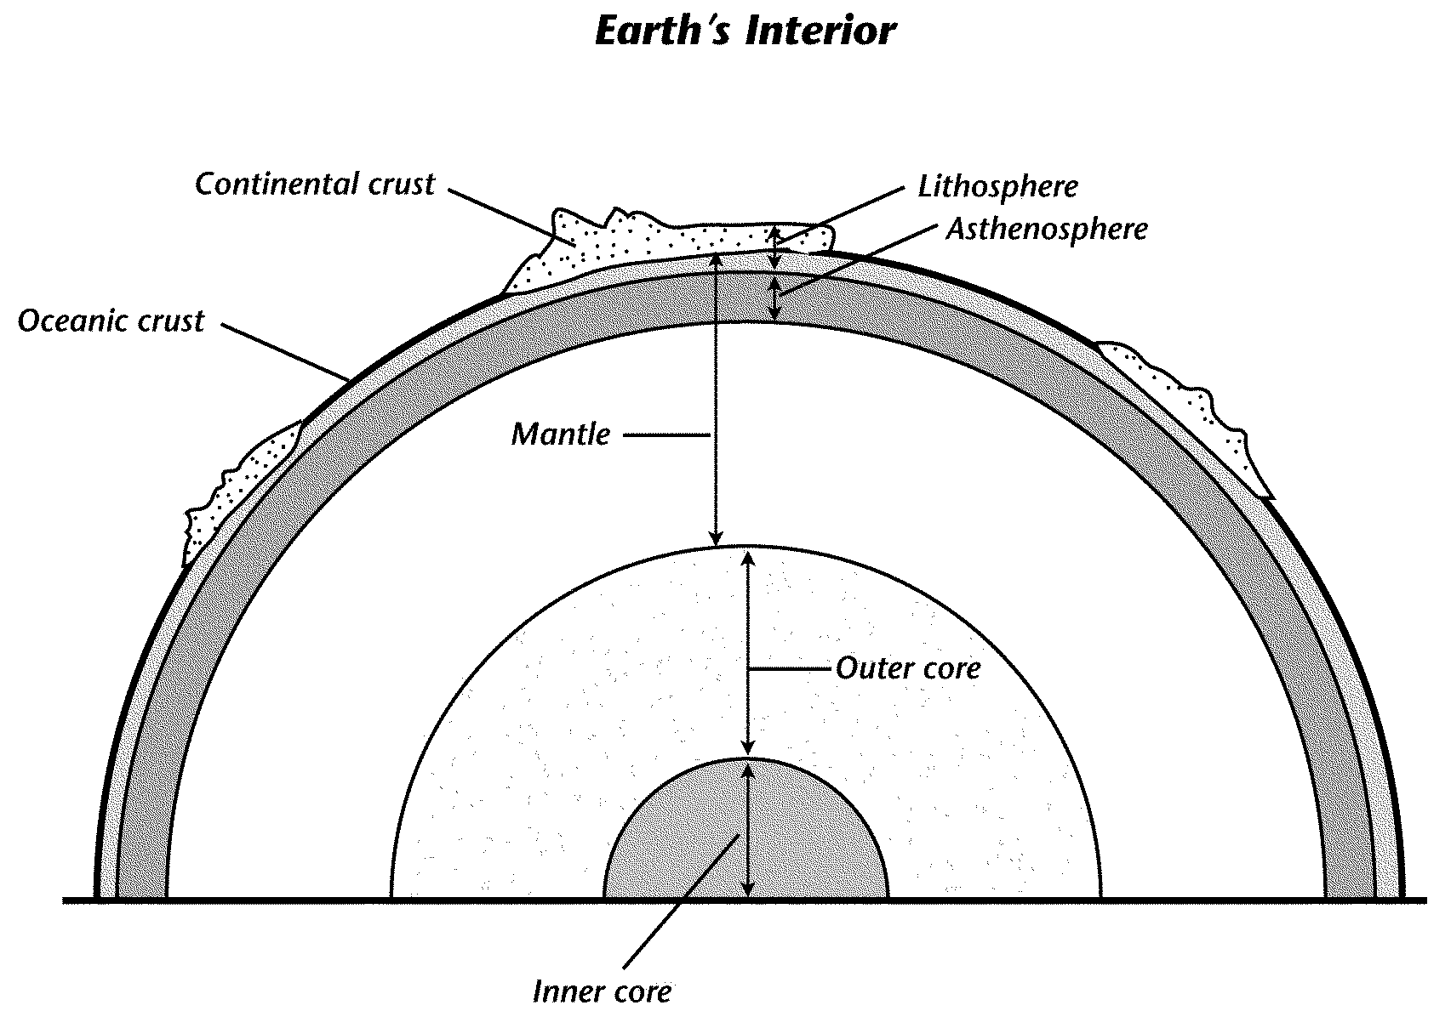

A proficient can: explain why the Earth’s layers are in the order they are.

9. Explain why the Earth’s layers are positioned like they are.
____________________________________________________________________________________________________________________________________________________________________________________________________________________________________________________________________________________________________________________________________________________________________________________________________________________________________________________________________________________________________________________________________________________________________________________________________________________________________________________________________________________________________________________________________________________________________________________________________________________________________________________________________________________________________________________________________________________________________________________________________________________________________________________________________________________________________________________________________________________________________________________________________________________________________

